Faaborg Sund Marathon
På tur til Thurø 20/12-2023
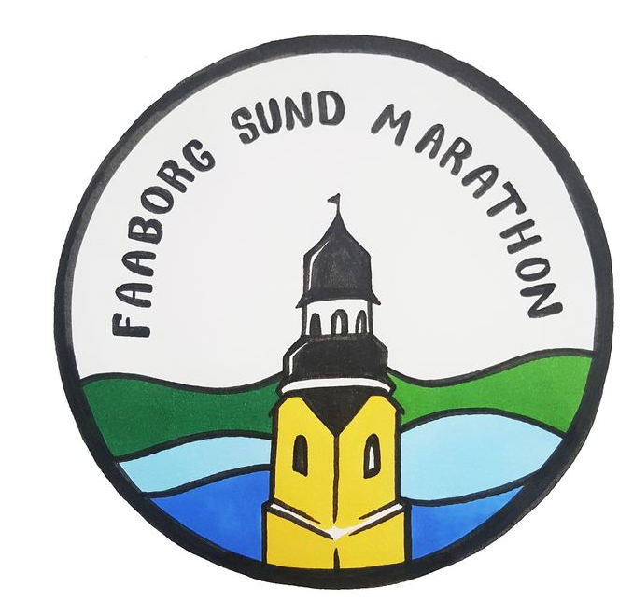
Halvmarathon : Jørgen Thomsen 2:15:30. Ella Kuhlman 2:30:34
Ulla Marie Steffensen : DNS

Marathon : Ane Marie Veggerskilde 5:03:59. Jens Mogensen 5:03:59. Peter Regius Møller 5:03:59. Alex Lundahl 5:03:59. Stig Kuhlman 5:34.20

